Agricultural project involves poultry keeping ,tree planting and vegetable production which was rolled out in Homabay, Siaya,Kisumu and vihiga counties in 2018 it is geared towards improving nutrition and food security to increase income for 2,100 small holder farmers to improve their income and enable them pay for their health insurance to access quality and affordable health care. The targeted sub counties and schemes counties are Muhoroni sub county (Ombeyi 1 &2)Bondo sub county (Sowesa) Alego Usonga sub county (KASTEP) Rachuonyo East sub county( Ogera), Rachuonyo north sub county( Lieta) Homabay Town sub county( Gewka) and Rangwe sub county (Tujipange) Sabatia sub county (Munoywa, Hope care givers . The Achievements for the project are 2,652 beneficiaries have been mobilized 24 Village Peer Groups of 35 members each trained on poultry keeping 700, each Small holder farmers with 5 trees each with 65 households have purchased poultry of so far 3500 chicks which has increased their capital base. The income has enabled farmers to pay school fees and built houses from selling vegetables and poultry

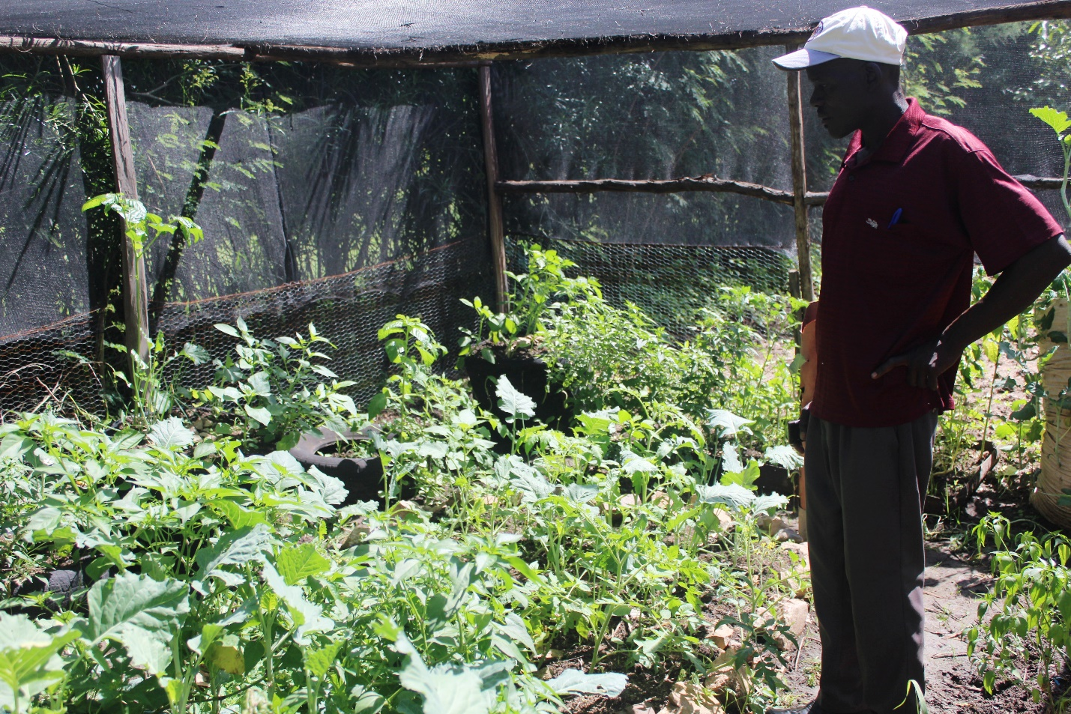

Figure 1 vegetable plantation in Awato

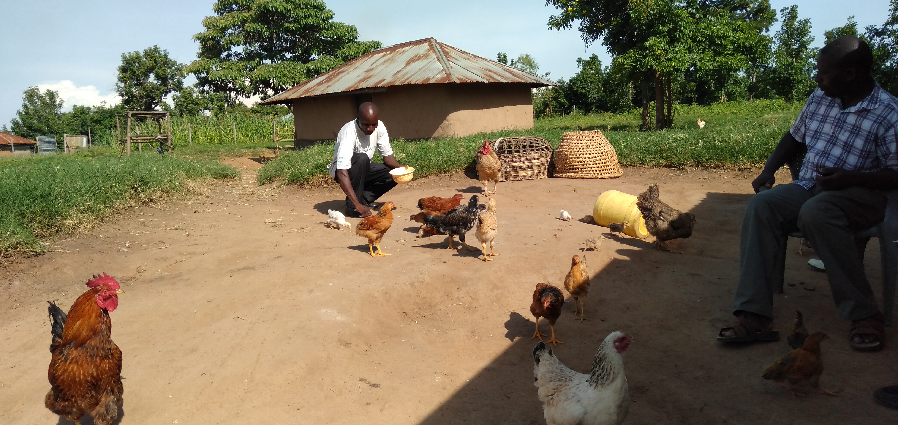

Figure 2 local poultry keeping in KASTEP

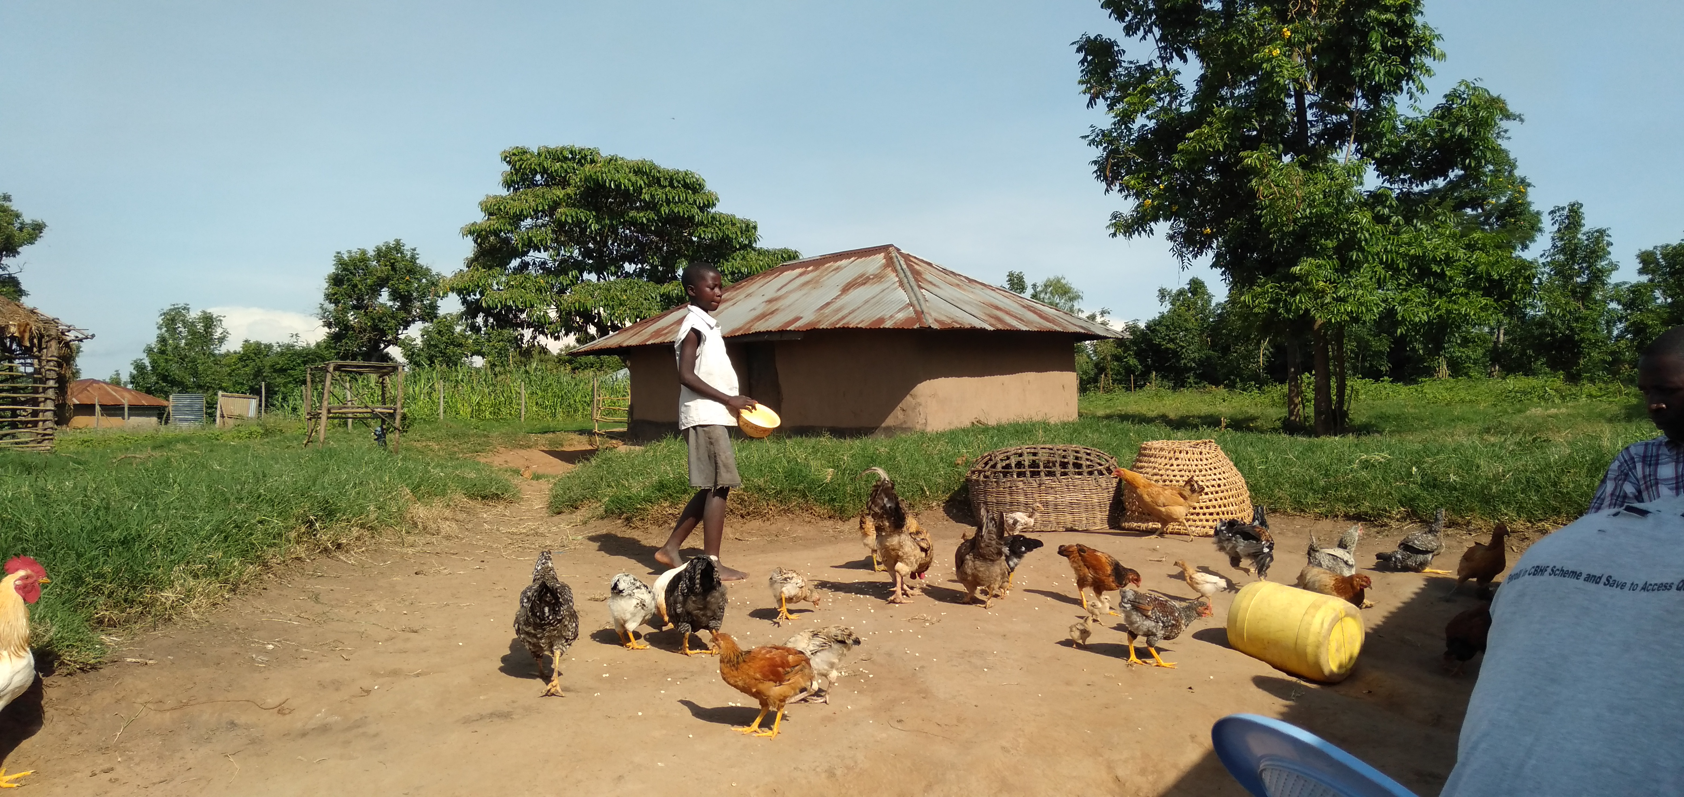

Figure 3 poutry keeping in siaya county